SIMATS ENGINEERING (SAVEETHA SCHOOL OF ENGINEERING)
Department of Computer Science and Engineering
CO1 ASSESSMENT TOOL 2 – Agile Sprint Planning &User Story Workshop
Course Code: | CSA10 | Course Title: | Software Engineering
CO Assessed: | CO1 | Assessment: | Assessment Tool 2 – Agile Sprint Planning  & User Story Workshop
Weightage: | 20% | Total Marks: | 25
CO1 Statement: | Apply advanced methodologies and agile project management techniques to manage software projects effectively
Student Name: | T.V.Sai Jagadeesh | Reg. No.: | 192472146
Section / Batch: | SLOT-C | Date: | 14\10\26

Code of Conduct
I T.V.Sai jagadeesh(192472146)certify that this submission is my original work and that I have adhered to the guidelines specified for this assessment. I understand that any violation of academic integrity rules will result in disciplinary action. Signature of the Student:T.Sai
Annexure A – Completed Agile Sprint Planning Workshop
1. Project Vision and Stakeholders:
Vision: Build a simple web application that enables student project teams to create projects, assign tasks, and track progress in one shared workspace. The first usable release will support a team leader and invited team members.
Problem statement: Teams that coordinate through messages and spreadsheets can lose task updates, duplicate work, and miss deadlines. A shared board will show who owns each task and its current status.

Project objectives
- Provide authenticated access and restrict each project to its members.
- Allow leaders to create projects and assign tasks with priorities and due dates.
- Display tasks in To Do, In Progress, and Done columns.
- Calculate progress from completed tasks and provide overdue notifications in later sprints.
Stakeholder | Role and interest
Student project leader  / Product Owner | Defines priorities, approves acceptance criteria, creates projects, and reviews the increment.
Team members / users | Receive assignments, update tasks, and provide usability feedback.
Stakeholder | Role and interest
Faculty guide / sponsor | Reviews project progress and confirms that the solution meets the assessment scope.
Student development team | Designs, implements, tests, and demonstrates the software.
Scrum facilitator | Coordinates planning and daily check-ins and helps resolve impediments; a student may rotate this role.
Application administrator | Maintains access, deployment settings, and backups.
Proposed environment: Browser interface, Python Flask service, and SQLite database for the classroom prototype. Roles are project leader and team member; administration is a separate maintenance responsibility.

2. Epics and User Stories
The following stories define the proposed product. Each story identifies a user, a feature, and a practical benefit. IDs provide traceability to acceptance criteria and backlogs.
Stor y | Epic | User story
US0  1 | E1 Access | As a team member, I want to register and sign in, so that I can securely access my projects.
US0  2 | E2 Projects | As a project leader, I want to create a project, so that my team has a shared workspace.
US0  3 | E2 Projects | As a project leader, I want to add registered members to my project, so that only the intended team can collaborate.
US0  4 | E3 Tasks | As a project leader, I want to create and assign a task with a priority and due date, so that responsibilities and deadlines are clear.
US0  5 | E3 Tasks | As a team member, I want to view my project board and update my assigned task status, so that the team can track current work.
US0  6 | E4  Visibility | As a project leader, I want to see the percentage of completed tasks, so that I can monitor project progress.
US0  7 | E3 Tasks | As a team member, I want to comment on a task, so that discussions stay linked to the work.
US0  8 | E4  Visibility | As a team member, I want an in-app alert for my overdue tasks, so that I can act on missed deadlines.
US0  9 | E3 Tasks | As a project member, I want to filter tasks by assignee and priority, so that I can locate relevant work quickly.
US1  0 | E4  Visibility | As a project leader, I want to export a task summary as CSV, so that I can report progress to my faculty guide.

Epic scope
E1 Access covers user identity and secure sessions. E2 Projects covers project creation and membership. E3 Tasks covers assignment, board updates, discussion, and retrieval. E4 Visibility covers progress, alerts, and reports.
Scope boundary: Chat, file uploads, automated AI assignment, and integration with external tools are excluded from the initial release. A lightweight classroom implementation is the intended outcome.
3. Acceptance Criteria:
Each criterion is a proposed testable requirement, not a claim that the software has already been built or tested. Criteria apply to both initial and later sprint stories.

US01
Given an unused valid email and a password of at least 8 characters, when registration is submitted, then one account is created and the password is stored as a secure hash.
Given an existing email, when registration is attempted again, then the duplicate is rejected. Given valid credentials, when login is submitted, then a session starts; invalid credentials show an error and no session starts.

US02
Given a signed-in leader, when a project name of 1–100 nonblank characters is submitted, then the project is created and the leader becomes its owner. A blank name is rejected.

US03
Given a project owner and an existing registered account, when that account is added, then it appears once in the membership list and can access the project. A duplicate member, unknown email, or non-owner request is rejected.

US04
Given a project owner, when a nonblank title, project-member assignee, valid due date, and High/Medium/Low priority are submitted, then one task is saved in To Do. An invalid or missing required field prevents creation.

US05
Given a project member, when the board is opened, then only that project’s tasks appear in To Do, In Progress, or Done. Given an assignee or project owner, when a valid status is selected, then it persists after refresh. A nonmember receives no project data; another member cannot modify an unassigned task.

US06
Given 3 completed tasks out of 5 total, when the dashboard loads, then progress is 60%. Given a project with no tasks, then progress is 0% and no division error occurs.

US07
Given a project member and a task, when a nonblank comment of at most 500 characters is posted, then its text, author, and timestamp appear under that task. Empty comments and nonmember requests are rejected.

US08
Given a task assigned to the signed-in user whose due date is before today and whose status is not Done, when alerts are opened, then the task appears once as overdue. Tasks due today or marked Done do not appear.

US09
Given a project board, when an assignee and/or priority filter is selected, then only matching tasks are shown. Clearing filters restores all authorized project tasks; no matches shows an empty-state message.

US10
Given a project owner, when Export is selected, then a CSV containing every task in that project is downloaded with task title, assignee, priority, due date, and status. A non-owner export request is rejected.
4. Prioritized Product Backlog:
Prioritization uses MoSCoW and a value-first dependency order. Must Have stories enable the complete create–assign–update workflow. Should Have stories improve communication and visibility after that workflow is reliable.
Ra  nk | ID | Prio  rity | Poi  nts | Depends on | Justification
1 | US01 | Must | 3 | None | Secure access is required before protected actions.
2 | US02 | Must | 2 | US01 | A workspace is required before membership or tasks.
3 | US03 | Must | 3 | US02 | Registered members are required before assignment.
4 | US04 | Must | 5 | US03 | Creates the core work items with ownership.
5 | US05 | Must | 5 | US04 | Makes the end-to-end workflow usable.
6 | US06 | Shou  ld | 3 | US05 | Summarizes reliable task status data.
7 | US07 | Shou  ld | 3 | US04 | Keeps task discussions in context.
8 | US08 | Shou  ld | 5 | US04,  US05 | Draws attention to incomplete overdue work.
9 | US09 | Coul  d | 3 | US05 | Improves retrieval when task volume grows.
Ra  nk | ID | Prio  rity | Poi  nts | Depends on | Justification
10 | US10 | Coul  d | 3 | US04,  US05 | Supports faculty reporting after core data exists.
Prioritization rationale:
Authentication protects project data. Projects and membership establish the permitted assignees. Task creation then provides records for the status board. Progress charts, alerts, and export depend on these records and can be delivered after the basic workflow.
Backlog refinement and change handling:
The Product Owner reviews feedback at the sprint review and may reorder future work. New requirements receive a story ID, acceptance criteria, dependencies, and an estimate before selection. Changes that threaten the current sprint goal are discussed with the development team and traded against comparable work rather than silently added.
Working assumptions:
All users share one classroom prototype instance. Users register before they can be added to a project. Each task has one assignee. A calendar date is used for due dates, and the application uses one configured local timezone. The prototype stores no sensitive institutional records.

5. Sprint Backlog and 6. Story Point Estimation
Sprint length: 10 working days. Proposed team: three student developers, each available for 2 focused hours per day. Gross capacity is 60 person-hours; 12 hours are reserved for meetings, integration, and contingency, leaving 48 hours for story work.
Sto ry | Actionable tasks | Owner | Hour  s | Point  s
US0  1 | Design user table (1h); build registration and password hashing (2h); implement login/logout and session guards (2h); test valid and invalid access (2h). | Develop er A | 7 | 3
US0  2 | Design project table (1h); build creation form/API (2h); add owner access and validate persistence (2h). | Develop er B | 5 | 2
US0  3 | Create membership relation (1h); add member-selection API/UI (3h); enforce owner-only action (1h); test duplicates and unauthorized requests (2h). | Develop er B | 7 | 3
Sto ry | Actionable tasks | Owner | Hour  s | Point  s
US0  4 | Create task schema (2h); build task form/API (4h); validate assignee, date, and priority (2h); test storage and error cases (3h). | Develop er C | 11 | 5
US0  5 | Build three-column board (4h); implement status update API (2h); enforce update permissions (2h); test status persistence and access isolation (4h). | Develop er A | 12 | 5
Estimation technique and justification:
Use Planning Poker with Fibonacci values 1, 2, 3, 5, 8, and 13. Team members estimate independently, discuss different assumptions, and re-estimate to agreement. Points represent relative complexity, effort, and uncertainty; they are not a fixed conversion to hours. These are proposed initial estimates, to be confirmed by the team.
US02 is the 2-point baseline because it is a small form with one main entity. US01 receives 3 points for credentials, secure storage, and session checks. US03 receives 3 points for membership validation and authorization. US04 receives 5 points for multiple fields, relationships, and validation. US05 receives 5 points for the board, state changes, persistence, and access control.
The 18-point commitment is an initial forecast, not historical velocity. Task hours provide a separate capacity check. If work exceeds capacity, simplify the board presentation while retaining its acceptance criteria, or renegotiate scope with the Product Owner.

7. Sprint Goal and Expected Deliverables:
Sprint goal: Enable a student project leader to create a secure project, add registered teammates, assign tasks, and track their progress through a shared three-column board.
Proposed sprint schedule:
Working days | Planned work and checkpoint
Day 1 | Confirm scope and criteria, plan the sprint, create the repository, and agree database interfaces.
Days 2–3 | Implement and test authentication and project creation. Begin membership and task UI with agreed interfaces.
Days 4–5 | Complete membership and task creation. Verify assignment uses project members only.
Days 6–7 | Complete board and status changes. Integrate access restrictions and persistence.
Days 8–9 | Run acceptance and regression tests; fix defects; prepare sample data and documentation.
Day 10 | Demonstrate the end-to-end workflow, review feedback, hold a retrospective, and refine the next backlog.
Expected deliverables at sprint end:
- A runnable prototype implementing US01–US05 with a shared project board.
- Database schema for users, projects, memberships, and tasks, plus repeatable setup instructions.
- Source code with installation steps, configuration guidance, and a short user guide.
- Acceptance test checklist recording pass/fail, evidence, and unresolved defects after actual execution.
- Sprint review demonstration and a revised backlog for the next sprint.
Definition of Done:
A selected story is Done only when its implementation is integrated, reviewed by another student, and passes all of its acceptance criteria. Relevant input validation and permission checks must pass, data must persist after refresh, and setup documentation must be updated.
No unresolved defect may block the sprint goal. The Product Owner reviews the demonstrated result against the agreed criteria.
Demonstration and measurable success:
Register two users, sign in as the leader, create a project, add the second user, and assign a
High-priority task with a due date. Sign in as its assignee and move it from To Do to In Progress and Done. Refresh to confirm persistence. Attempt access with a third, nonmember account and verify denial. Success requires all US01–US05 criteria to pass; actual test results must be recorded only after execution.
Risks and next sprint:
Authentication or membership delays can block integration; agree interfaces on Day 1 and integrate early. Limited availability is handled through the 6-hour capacity buffer and daily impediment checks. The next sprint should prioritize US06 and US07, then assess US08 against available capacity. No future story is promised before refinement.
Output:
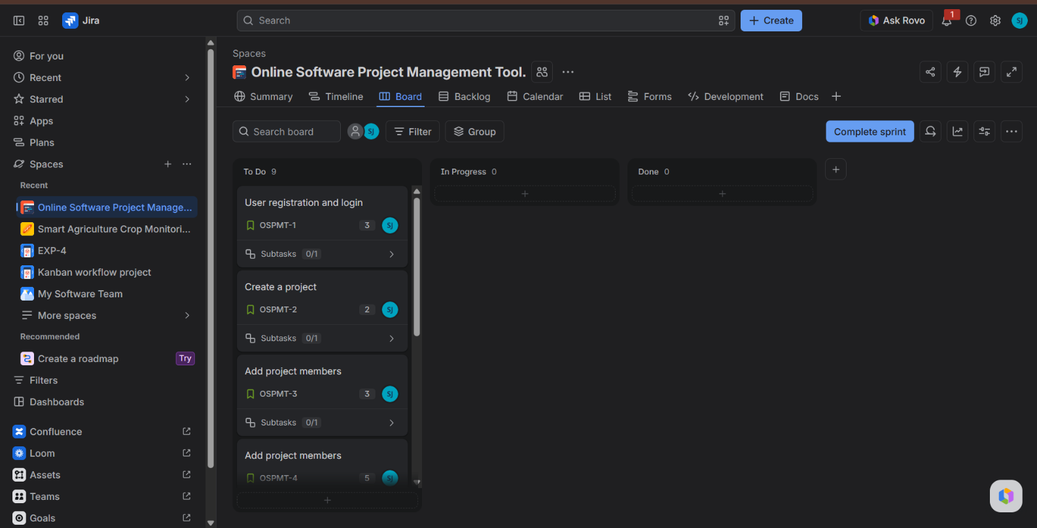

Rubrics for Calculation
Criteria | Excellent (5  Marks) | Good (3 Marks) | Satisfactory (2  Marks) | Needs  Improvement  (1 Mark)
Project Vision  &  Stakeholder  Identification  (30%) | Project vision is clear, comprehensive, and aligned with the problem statement. All relevant stakeholders and their roles are correctly identified. | Vision is clear with minor omissions. Most stakeholders are correctly identified. | Vision is partially defined. Some stakeholders are missing or incorrectly identified. | Vision is unclear or incomplete. Stakeholders are poorly identified or missing.
Epics & User  Stories (25%) | Epics are welldefined and user stories are complete, follow Agile format, and fully capture functional requirements. | Epics and user stories are mostly complete with minor formatting or requirement issues. | User stories are partially complete with limited Agile structure. | User stories are incomplete, unclear, or do not follow Agile practices.
Acceptance  Criteria  (20%) | Acceptance criteria are specific, measurable, testable, and aligned with all user stories. | Acceptance criteria are mostly clear and testable with minor gaps. | Acceptance  criteria are partially defined and lack clarity or completeness. | Acceptance criteria are missing or not aligned with user stories.
Product Backlog  Prioritization  & Sprint  Planning | Product backlog is logically prioritized, sprint backlog is realistic, and task | Backlog prioritization and sprint planning are mostly appropriate with | Prioritization or sprint planning is partially complete with | Backlog  prioritization and sprint planning are poorly
(15%) | breakdown is complete. | minor issues. | limited justification. | organized or incomplete.
Story Point  Estimation,  Sprint Goal &  Presentation  (10%) | Story point estimation is well justified, sprint goal is clear, deliverables are realistic, and presentation is professional and well organized. | Estimation and sprint goal are mostly appropriate with minor inconsistencies. Presentation is clear. | Estimation or sprint goal lacks justification. Presentation is adequate but incomplete. | Estimation is unrealistic or missing. Sprint goal, deliverables, and presentation are unclear or incomplete.

Criteria | Mark
Project Vision & Stakeholder Identification (30%) | /5
Epics & User Stories (25%) | /5
Acceptance Criteria (20%) | /5
Product Backlog Prioritization & Sprint Planning (15%) | /5
Story Point Estimation, Sprint Goal & Presentation (10%) | /5
TOTAL | /25

